The important decisions in software development vary with the scale of the context that we're thinking about. A common scale is that of an application, hence "application architecture".

One of the undecided problems of software development is deciding what the boundaries of a piece of software is. (Is a browser part of an operating system or not?) Many proponents of Service Oriented Architecture believe that applications are going away - thus future enterprise software development will be about assembling services together.

The first problem with defining application architecture is that there's no clear definition of what an application is. My view is that [applications are a social construction](https://martinfowler.com/bliki/ApplicationBoundary.html):

* A body of code that's seen by developers as a single unit
* A group of functionality that business customers see as a single unit
* An initiative that those with the money see as a single budget

Such a loose definition leads to many potential sizes of an application, varying from a few to a few hundred people on the development team. (You'll notice I look at size as the amount of people involved, which I feel is the most useful way of measuring such things.) The key difference between this and enterprise architecture is that there is a significant degree of unified purpose around the social construction.

All of these are social things. We can draw application boundaries in hundred arbitrarily different ways. But it's our nature to group things together and organize groups of people around these groups. There's little science in how this works, and in many ways these boundaries are drawn primarily by human inter-relationships and politics rather than technical and functional considerations. To think about this more clearly I think we have to recognize this uncomfortable fact.

**Domain Driven Design**

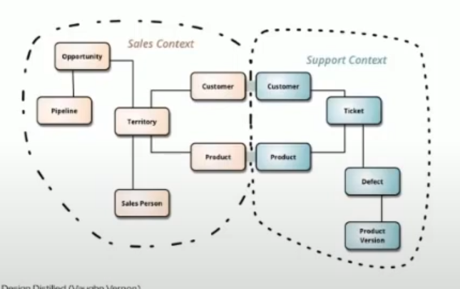

Допустим у нас есть приложение, где каждый модуль состоит еще из подмножества модулей (функциональностей).

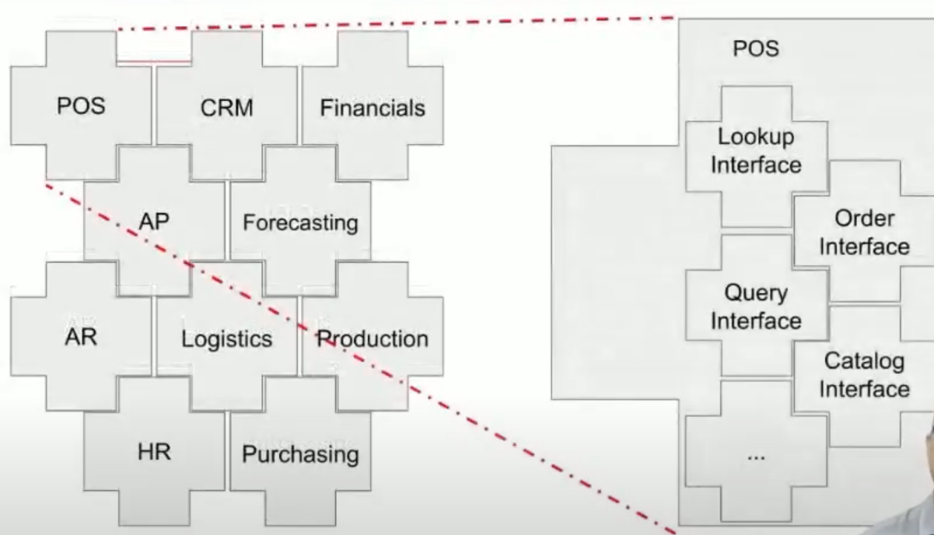

Если, допустим, модуль POS тратит слишком много ресурсов на IO базы данных, то мы можем создать отдельный инстанс БД только для этого модуля